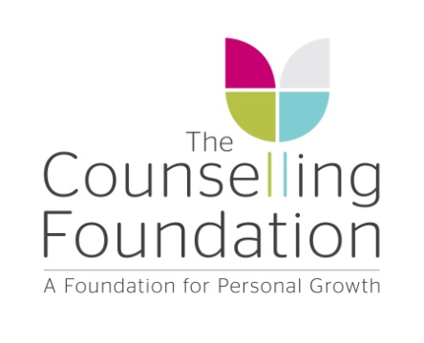

Report Code No:
EOY TSA Th D2

HAND-IN DEADLINE: Friday 25th June 2021

TRAINEE SELF ASSESSMENT SEMINARS

Diploma Year 2

Name

The aims of this Module are to enable students to:

- Further develop an understanding of the differences between psychodynamic schools.

- Further develop a personal synthesis of psychodynamic theory and practice.

- Reflect on personal experience as individuals and group members.

Based on your participation in seminars, please comment on:

1) Your knowledge of different approaches to psychodynamic theory.
a) Please give an example to demonstrate your understanding during this year.

b you) Which texts and activities have you found helpful and which least helpful?

What brings you here ? An exploration Of the unconscious motivations of those people who choose to train to work as a psychotherapist and counsellor

2) Your capacity to further develop a personal synthesis of theory and practice.
a) Do you think you have the grounding to do this?

b) Which texts and activities have you found helpful and which least helpful?

c) What has been the most important piece of learning for you arising from the seminars?

3) From your practical skills work (role-plays) how has your ability to identify unconscious processes developed:

4) How has the seminar experience helped your development as a practitioner of counselling skills? (Applicable to students engaged in clinical practice only).

5) Is there anything else to which you would like to draw to the attention of the Assessment Committee?

5) Is there anything else to which you would like to draw to the attention of the Assessment Committee?

IS THERE ANY REASON OR ISSUE THAT IS OUTSTANDING THAT WILL AFFECT YOUR ONGOING ABILITY TO COMPLETE OUR TRAINING THAT YOU FEEL WE SHOULD KNOW

Please be as comprehensive as possible:

Signed (Trainee) ………………………………Date ……………………………….…

DEADLINE: 25th June 2020

