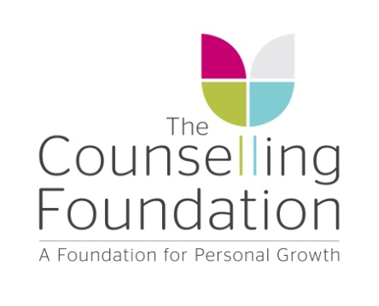

Report Code No:
EOY STA AD1

HAND-IN DEADLINE: Friday 18th June 2021

SEMINAR TUTOR ASSESSMENT

Advanced Diploma Year 1

Student Name: Course:

Course Learning Outcomes

On successful completion of these seminars trainees will be able to demonstrate the following academic attainments:

- An ability to compare and contrast the theories studied.

- An ability to discuss the relevance of the theories studied to their own clinical practice.

- A deepening understanding of unconscious processes.

- An understanding of how internal and external worlds meet to influence the personality.

1) Based on the trainee’s participation in seminars, please comment on:

a) The trainee’s appreciation of the differences between psychodynamic schools.

b) The trainee’s ability to compare, contrast and evaluate these different theories to clinical work.

.

c) The trainee’s ability to link theory and practice in an individual way.

d) The trainee’s understanding of unconscious processes.

.

2) Is there anything else to which you would like to draw to the attention of the Assessment Committee?

Signed (Seminar Tutor): Date:

DEADLINE: Friday 18th June 2021

