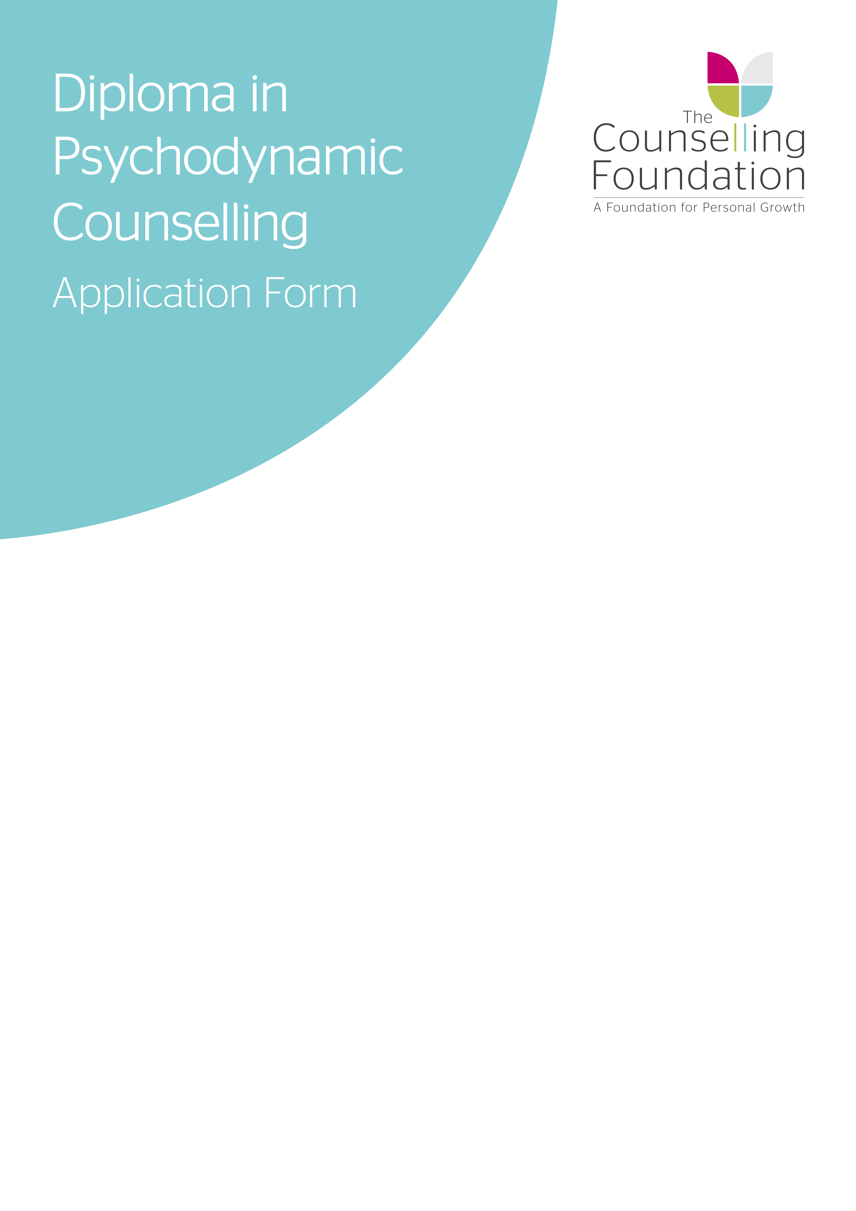
2020 - 2022
Please complete form WORD PROCESSED ONLY
Full Name: |  |  |  | Title:
Email Address: |  |  |  | Date of Birth:
Address:

Mobile Number:
FOR OFFICE USE ONLY
Date of Receipt: |  | Application Number: | Deposit: |  | Registration:
STA / BED | M / T / W | AM / AFT / PM | Allocation #
Date of Acknowledgement: |  | Offer Date: | Acceptance Received:
It is essential that whilst on this course you provide The Training Centre with a personal email address that other people do not have access to. A work email address or group family email is not acceptable due to the sensitive nature of some correspondence that you may have with your tutor.

PREFERRED TRAINING LOCATION
Please identify your first and second preference (where applicable) of training time and location:

BEDFORD The Counselling Foundation
7A St Pauls Square
Bedford
MK40 1SQ

 |  |  | 1st | 2nd
Evening | Monday | 6:00pm – 9:30pm
Daytime | Tuesday | 10:00am – 1:30pm

ST ALBANS The Counselling Foundation Training Centre
College Yard
Lower Dagnall Street
St Albans
AL3 4PA

 |  |  | 1st | 2nd
Daytime | Wednesday | 10:00am – 1:30pm
Afternoon | Wednesday | 2:00pm – 5:30pm
Evening | Wednesday | 6:00pm – 9:30pm

Dates, times and course venues are set according to demand and so are subject to change. The Training Centre reserves the right to cancel and rearrange the courses if recruitment does not reach the minimum numbers. Any monies paid for cancelled courses will be refunded.

ABOUT YOU
Please complete form WORD PROCESSED ONLY and answer the questions below noting that all answers will be kept strictly confidential.
- What has led you to make your application to join the Diploma Course Programme now?

- Please list relevant counselling courses attended of at least one year’s duration:

- What experience of counselling work or work within a helping relationship do you have?
Please be specific about the nature and extent of your work and whether it is in a voluntary or paid capacity.

Please give an account of significant life experiences/changes/loss and how you feel towards them (between 250 – 500 words).

Details of any significant emotional or physical illness
Please indicate if you have received personal counselling, psychotherapy, psychoanalysis or any sort of psychiatric help any time in your life. Please state any illness for which you have been treated in the last two years:

- Have you received treatment in the last 3 years for any form of addiction? If so, please state briefly.

- Do you have any special needs/disabilities, which we should be aware of when considering your application? If so, please state briefly.

Have you, or a family member, had contact with one of our Counselling Centres; either in the past or currently?
If yes, please specify which centre and the nature of the involvement.

Please note that subject to circumstances, a criminal record will not necessarily prevent you from becoming a Diploma qualified counsellor. Trainees are required to hold Disclosure & Barring Service (DBS) prior to and for the full duration of their placement.

Have you ever had any convictions (spent or unspent), cautions or pending cases that are not protected under the Rehabilitation of Offenders Act (1974)?
If yes, please supply details noting that all details will be kept strictly confidential.

Is there anything else you would like to let us know about yourself, your circumstances or your application?

How did you hear about our training courses?

REFERENCES

INTERNAL AND EXTERNAL APPLICANTS
Referee 1: We would like a character reference from someone who knows you in a work or training capacity, but is neither a member of the Foundation staff or a student on any of our courses. Your Foundaction Certificate tutor will provide the selection panel with a report on your work in the seminars.

Name ________________________________________________________________________
Address ______________________________________________________________________
__________________________________________Postcode ___________________________
Tel __________________________________________________________________________
E-mail ________________________________________________________________________

EXTERNAL APPLICANTS ONLY

Referee 2: We would like an academic reference from your previous Course Tutor.

Name ________________________________________________________________________
Address ______________________________________________________________________
__________________________________________Postcode ___________________________
Tel __________________________________________________________________________
E-mail ________________________________________________________________________

COURSE FEES
A payment of £425 (£125 registration fee and £300 deposit) is payable at the time of application.

You may cancel your application and you will be refunded all monies any time up to 14 days from receipt of your application form. After 14 days the registration payment of £125 is transferrable, but non-refundable. The deposit will be taken off your course fees if you are successful in securing a place on the course. Please note the £300 deposit is refundable in the event that your application is unsuccessful. You will be informed of this decision in writing by the 13th July 2020. Any refund will be paid within 30 days of notification.

Payment of the deposit allows you to apply and be considered for (but not guaranteed) a place on the course at The Counselling Foundation and enables The Counselling Foundation to plan the Diploma for the upcoming academic year.

Our courses are likely to be oversubscribed and places are limited. We therefore encourage early applications and those applicants who return their form by the 28th March 2020 will be eligible to take advantage of an early booking discount when this year’s course fees are paid in full.

PAYMENT OPTIONS
For those students starting the Diploma year 1 training in 2020/21 the course fees with be £4,290.

Following payment of your £125 registration fee and £300 deposit, the balance of the fees can be paid via one of the following options:

Please tick one of the following:
√ | OPTION | PRICE |  | PAYMENT DATE
 | Instalments | £4,290 |  | Deposit and Direct Debit information to be received within 14 days of offer
 | Instalments | £1680  initial deposit followed by | £231.00  monthly payments from September to June by direct debit
 | Early booking  payment in full  *Only for applications received by 28th March 2020 | £3,890  (Save £400) |  | To be received within 14 days of offer
 | Payment in full | £3,390  (Save £300) |  | To be received within 14 days of offer
 | Payment by employer | £3,990 |  | Payment to be received within 30 days from invoice date
 | Personal payment plan | Please contact the finance team upon offer to discuss payment terms noting that a deposit will be required within 14 days of an offer being made to secure your place on the course. Contact can be made by emailing accounts@counsellingfoundation.org or calling 01727 868 585 option 4.

SUPERVISION FEES

Supervison fees will only apply once a student has secured an Internal Placement. Information on placements will be sent to students at the beginning of the academic year.
Students are not guarrented an Internal Placement and will need to apply for a placement of their choice.

The fee for internal supervision for Diploma year 1 training in 2020/21 will be £810.

Upon offer of an Internal Placement during the academinc year these fees can be paid in three instalments of £270. Please contact the finance team for more details of this option.

External placement fees will be listed in the placement document that you will receive at the start of the academic year.

PAYMENT METHODS

BANK TRANSFER
Payment is preferred by electronic bank transfer. Please use the details below to transfer payment over to the counselling Foundation. Please reference all bank transfers with your surname.

Account name | The Counselling Foundation
Account number | 00083770
Sort code | 40-52-40

INVOICE
You can pay via invoice which is sent to the email address on this application. With this method you can use a debit or credit card or paypal to make payment.

PAYMENT BY EMPLOYER
If your fees are being paid by your employer please complete the information below:-

Company Name: ___________________________________________________________________
Company Address__________________________________________________________________
_________________________________________________________________________________
Contact Name:_____________________________________________________________________
Contact Email Address:______________________________________________________________
Telephone Number:_________________________________________________________________
For queries around payment of the course fees, please e-mail accounts@counsellingfoundation.org or call 01727 868 585 option 4.
PERSONAL THERAPY

Students who would like to apply for the Diploma and Advanced Diploma should be with therapists who work in a way that is congruent with the psychodynamic approach, and meet the minimum requirements set out by the Counselling Foundation Training Centre. Students are required to be in weekly personal therapy six months prior to the Diploma course commencing.

THERAPIST CRITERIA

QUALIFICATIONS
- Advanced Diploma/Post-Graduate level and above
- Evidence of at least 2 years training in the psychodynamic model

EXPERIENCE
- 3 years post-qualifying experience
- Currently working from a psychodynamic orientation

THEIR ACCREDITATION

With one of the following professional bodies: BACP, UKCP (Psychodynamic Section), BPC.

RELATIONSHIP WITH THE COUNSELLING FOUNDATION

The Counselling Foundation reserves the right to withhold consent if, in it’s reasonable opinion, it is not in the best interests of the student to commence work with that therapist. Including, without limitation, where the therapist in question does not have a constructive relationship with The Counselling Foundation.

THERAPIST FORM

Please enter your therapist’s details here (use BLOCK CAPITALS):

Name of Therapist __________________________________________________________________

Address __________________________________________________________________________

_____________________________________________________Postcode ____________________

Telephone________________________________________________________________________

Therapist email address _____________________________________________________________

Name of Therapist’s Training Organisation _______________________________________________

a) Date started___________________________ b) Frequency ______________________________
DATA PROTECTION
Your details will be maintained on our electronic systems to allow us to contact you about your application and the course, including to ask for feedback. Your details will not be shared with other organisations. You can unsubscribe at any time by contacting training@counsellingfoundation.org

- I give permission for my details to be used to contact me about this and selected other courses at the Foundation.
- I give permission to be contacted about this course only.

I am applying for the Diploma in Psychodynamic Counselling Skills & Theory course (2020-22) on the basis of the Course Brochure and this Application Form. I have read and understood the Terms and Conditions of this course as outlined on the course web page http://www.counsellingfoundation.org/training/diploma-in-psychodynamic-counselling/
I accept that the cost of this course will be as stated above and I agree to pay this fee either in full before the course begins or in the above instalments. Should I withdraw from the course for any reason during the year, I accept that I remain liable for the whole fee for that year, and I shall settle any outstanding balance without delay. I understand that the Foundation reserves the right not to run a course if recruitment does not reach required numbers. In this event any monies paid will be refunded to me.
I confirm that the information given in this application form is true, complete and accurate. No information requested or other relevant information has been omitted.

I accept that failure to disclose a convitction, or pre-existing medical or mental health condition which later comes to light may result in withdrawal, suspension or deferral of a place on the course.

Signed ___________________________ Print Name ___________________________

Date ___________________________
CHECKLIST

Documents that need to be returned for your application:

- Completed and signed Application Form

- A copy of your current CV

- Your registration fee of £125* [This fee is non refundable]

- Your deposit of £300

- Your completed Equal Opportunities Form

- A copy of your Course Tutor Reference (external applicants only)

- Your completed Therapist Form

Please email your application to training@counsellingfoundation.org or post to the address below:

The Counselling Foundation Training Centre
1 College Yard
Lower Dagnall Street
St Albans
AL3 4PA

DEADLINE FOR RECIEPT OF APPLICATIONS
18TH MAY 2020

