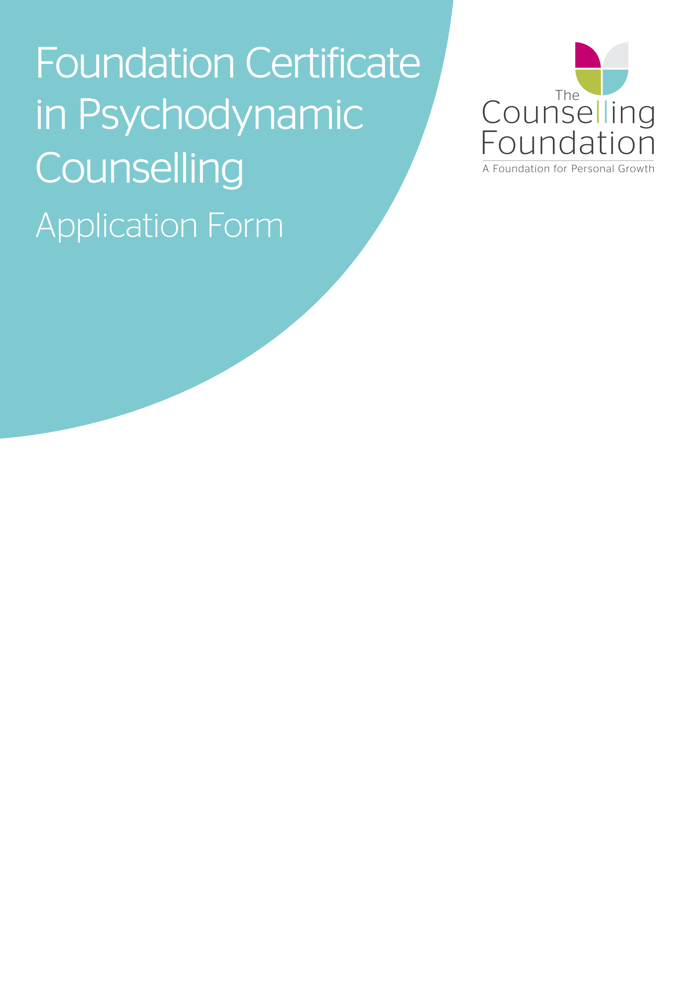
2020 - 2021
Please complete form WORD PROCESSED ONLY
Full Name: |  |  |  | Title:
Email Address: |  |  |  | Date of Birth:
Address:

Mobile Number:
FOR OFFICE USE ONLY
Date of Receipt: |  | Application Number: | Registration:
LDN | AM / PM | Allocation # | PF:
Date of Acknowledgement: |  | Offer Date: | Acceptance Received:
It is essential that whilst on this course you provide The Training Centre with a personal email address that other people do not have access to. A work email address or group family email is not acceptable due to the sensitive nature of some correspondence that you may have with your tutor.

PREFERRED TRAINING LOCATION
Please tick your first and second preference (where applicable) of training location:

CLAPHAM London Connected Learning Centre,
Rectory Grove,
London,
SW4 0EL

 |  |  | 1st | 2nd
Daytime | Wednesday | 10:00am – 2:00pm
Evening | Wednesday | 5:45pm – 9:30pm

Dates, times and course venues are set according to demand and so are subject to change. The Training Centre reserves the right not to run the course if recruitment does not reach the minimum numbers and any monies paid will be refunded.

If the above proposed days, times are not suitable, please select your preference from the options below:
Day & Time (Please circle):
 | Mornings | Evenings
Monday | 10.00am - 2.00pm | 5.45pm - 9.30pm
Tuesday | 10.00am - 2.00pm | 5.45pm - 9.30pm
Wednesday | 10.00am - 2.00pm | 5.45pm - 9.30pm
Thursday | 10.00am - 2.00pm | 5.45pm - 9.30pm
Friday | 10.00am - 2.00pm

HERFORDSHIRE AND BEDFORDSHIRE
For courese based in Hertfordshire and Bedfrodshire please download out Herts and Beds application form which can be found online here:
https://counsellingfoundation.org/training/foundation-certificate-in-psychodynamic-counselling/

ABOUT YOU

Please answer the questions below noting that all answers will be kept strictly confidential.
- Have you already completed an introductory course in counselling skills?

Yes No (please circle)
If ‘yes’ please give details of the course(s) completed:
Name of course ____________________________________________________________
Name of College____________________________________________________________
Duration of course __________________________________________________________
Dates when undertaken/completed _____________________________________________
Please provide information as to what you gained from this course:

- Why would you like to do this course? What are you hoping to gain from it? Why do you want to do the course now, at this time in your life?

- What events or circumstances in your life do you feel draw you to the practice of counsellor training?

- What opportunities do you currently have to practise counselling skills either as part of your paid employment or as a voluntary worker?
(If none, indicate what opportunities you might be able to develop in this area).

- Have you ever had personal counselling or therapy?

Yes No (please circle)

If yes, please highlight the circumstances that led you to seek counselling.

Reminder: Such information will be regarded as strictly confidential

Have you, or a family member, had contact with one of our Counselling Centres; either in the past or currently?
If yes, please specify which centre and the nature of the involvement.

- Briefly describe your personal strengths and limitations/weaknesses as they relate to your desire to study counselling at certificate level.

- What would you list as your significant life events/changes/loss?

- Which would you list as being your key/important relationships, such as partner, spouse, sibling, child, other family member, friend, etc?

- Should your application be successful what changes do you envisage in your personal life as a consequence of undergoing this course of study?

- Do you have any special needs/disabilities, including any special need for learning support, which we should be aware of when considering your application? If so, please state briefly.

- Do you have any physical or mental health conditions which may affect your ability to participate or complete the course? If so please state briefly.

Please note that subject to circumstances, a criminal record will not necessarily prevent you from continuing your training; however, a Disclosure & Barring Service (DBS) is required for the continuation of training beyond this course.

- Have you ever had any convictions (spent or unspent), cautions or pending cases that are not protected under the Rehabilitation of Offenders Act (1974)?
If yes, please supply details noting that all details will be kept strictly confidential.

- Is there anything else you would like to let us know about yourself, your circumstances or your application?

- Have you received treatment in the last 3 years for any form of addiction? If so, please state briefly.

- How did you find out about our training courses?

COURSE FEES
A £110 registration fee is payable at the time of application.

You may cancel your application and you will be refunded all monies any time up to 14 days from receipt of your application form. After 14 days the registration fee is non-refundable.

Subject to receipt of the application form and the registration fee, successful candidates will be required to pay the course fees in accordance with the below options no later than 14 days of The Counselling Foundation offering you a place on the Certificate course in writing.
PAYMENT OPTIONS
The Foundation Certificate course fee for 2020/21 is £2415 + £110 registration fee
Following payment of your £110 registration fee, the course fees can be paid via one of the options below.

Please tick one of the following:

√ | OPTION | PRICE |  | PAYMENT DATE
 | Instalments | £2,415 |  | Deposit and Direct Debit information to be received within 14 days of offer
 | Instalments | £630  initial deposit followed by | £178.50  monthly payments from September to June by direct debit
 | Early booking  payment in full  *Only for applications received by 4th April 2020 | £2,150  (Save £265) |  | To be received within 14 days of offer
 | Payment in full | £2,250  (Save £165) |  | To be received within 14 days of offer
 | Payment by employer | £2,250 |  | Payment to be received within 30 days from invoice date
 | Personal payment plan | Please contact the finance team upon offer to discuss payment terms noting that a deposit will be required within 14 days of an offer being made to secure your place on the course. Contact can be made by emailing accounts@counsellingfoundation.org or calling 01727 868 585 option 4.

PAYMENT METHODS

Payment is preferred by electronic bank transfer. Please use the details below to transfer payment over to the counselling Foundation:

Account name | The Counselling Foundation
Account number | 00083770
Sort code | 40-52-40

Please reference all bank transfers with your surname.

Alternatively, you can pay via invoice which is sent to the email address on this application. With this method you can use card or paypal to make payment.

PAYMENT BY EMPLOYER

If your fees are being paid by your employer please complete the information below:-

Company Name: ___________________________________________________________________
Company Address__________________________________________________________________
_________________________________________________________________________________
Contact Name:_____________________________________________________________________
Contact Email Address:______________________________________________________________
Telephone Number:_________________________________________________________________

For queries around payment of the course fees, please e-mail accounts@counsellingfoundation.org.
DATA PROTECTION

Your details will be maintained on our electronic systems to allow us to contact you about your application and the course, including feedback. Your details will not be shared with other organisations. You can unsubscribe at any time by contacting training@counsellingfoundation.org

Please tick one of the following ooptions:

- I give permission for my details to be used to contact me about this and selected other courses at the Foundation.

- I give permission to be contacted about this course only.

I am applying for the Foundation Certificate in Psychodynamic Counselling Skills and Theory Course (2020 - 21) on the basis of the Course Brochure and this Application Form. I have read and understood the Terms and Conditions of this course as outlined on the course web page
http://www.counsellingfoundation.org/training/foundation-certificate-in-psychodynamic-counselling/

I accept that the cost of this course will be as stated above and I agree to pay this fee either in full before the course begins or instalments as detailed. Should I withdraw or defer from the course for any reason during the year, I accept that I remain liable for the whole fee for that year, and I shall settle any outstanding balance without delay. I understand that The Foundation reserves the right to withdraw a course if the required numbers are not met. In this event any monies paid will be refunded to me.

I confirm that the information given in this application form is true, complete and accurate. No information requested or other relevant information has been omitted.

I accept that failure to disclose a convitction, pre-existing medical or mental health condition which later comes to light may result in withdrawal, suspension or deferral of a place on the course.

Print Name _______________________________________________________

Signed _______________________________________________________

Date _______________________________________________________

CHECKLIST

Documents that need to be returned for your application:

- Completed and signed Application Form

- A copy of your CV

- Your registration fee of £110 [This fee is non refundable]

- Your completed Equal Opportunities Form

Please email you application form to training@counsellingfoundation.org or post to the address below:
The Counselling Foundation Training Centre
1 College Yard
Lower Dagnall Street
St Albans
AL3 4PA

DEADLINE FOR RECEIPT OF APPLICATIONS
31ST AUGUST 2020

