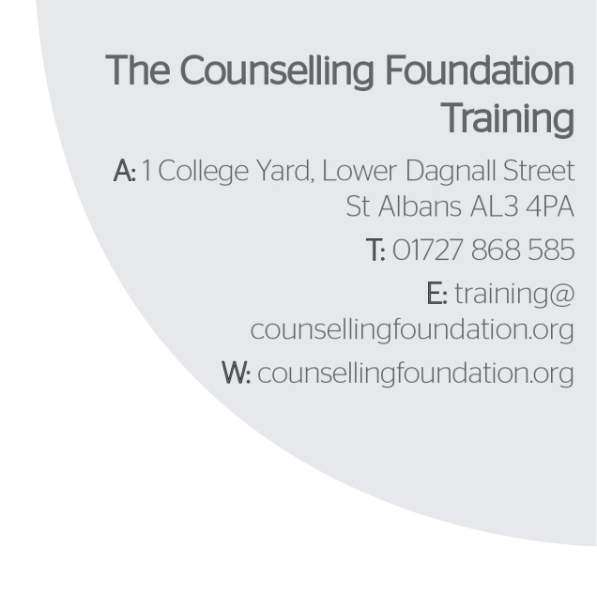
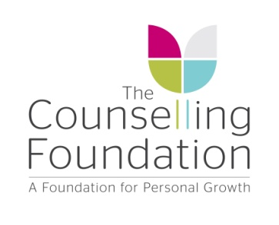

OBTAINING A CLINICAL PLACEMENT ACEDEMIC YEAR 2019-20

Every student enrolled on the Diploma & Advanced Diploma courses will need to undertake work with clients in a counselling centre for the duration of their training. This is referred to as a clinical placement. All Diploma student counsellors need to secure a clinical placement by Term 2.

Types of Clinical Placements

There are two types of Clinical Placements, those held in an Internal Centre or an External Centre.

INTERNAL CLINICAL PLACEMENTS

At the Training Centre we are able to place some student applicants within our Counselling Foundation counselling centres which we refer to as an Internal Centre and/or an Internal Placement.

EXTERNAL CLINICAL PLACEMENTS

We have many other approved counselling centres we have worked with historically. These are counselling centres from various different agencies and charities and are based in wide ranging areas from London to Berkshire and from Hertfordshire, Bedfordshire to Northamptonshire. These approved agencies are referred to as External Centres and/or External Placements. We are always adding to our list of approved External Centres. If any students would like us to approve an agency near where they live or work they should contact the Programme Tutor with further details and a site visit will be conducted as part of the approval process.

APPLYING FOR AN INTERNAL CLINICAL PLACEMENT

Students are encouraged to apply directly to the individual centres to enquire whether there are vacancies within those centres. On our list of agencies provided on the grid below you will find both Internal and External Centres. The following procedure is given as a guide to get started:

- Fill in the registration form and email it to CLINICALHEADS@COUNSELLINGFOUNDATION.ORG
- A Centre Head will contact you to arrange an interview.
- Complete the criteria needed to start seeing clients and return a signed Placement Contract to the training office.
- If the above criteria is not completed, you will not be allocated any clients in your Internal placement.

Please note that students may be charged for supervision, Mid Year and End of Year Reports in some external placements. In some cases this may be for group supervision or for individual supervision. A minimum of 1 and half hours per month individual supervision, or 6 hours a month for group supervision must be undertaken. Please enquire on application to individual placements if additional supervision costs are levied.
Procedures in applying for a Clinical Placement:

- External Placements: Select a counselling centre from the list below and email or telephone them to ask about their procedure in applying for a trainee counsellor position. You may need to complete their application form.
Internal Placements: Complete a Placement Registration Form and email to the centre heads email address which is CLINICALHEADS@COUNSELLINGFOUNDATION.ORG

- Internal Placements: Preference will be given to students on the Diploma and Advanced Diploma courses. The vacancies within each Centre will be reviewed quarterly and if more placements become available notification of any vacancies will be sent out to students and/or posted on our website.

- Only one internal placement is permitted although you may have more than one external placement. Trainees can hold a placement with The Counselling Foundation St Albans Bereavement Service and one other internal placement within a Counselling Foundation Centre. We do not recommend holding more than 2 clinical placements at any one time.

- Clinical hours that you accrue can only be counted towards your training if the client work and associated supervision is psychodynamic. Clients must be aged 18 and over.

- Students may apply to the course Programme Tutor for a new counselling centre (not currently on our approved list) to become an approved clinical placement centre. Please ask the course Programme Tutor for guidance on how to begin this process.

- Should you be offered a clinical placement in an external centre that is not on the list below, you must apply to the course Programme Tutor for permission to work in that centre. Each clinical placement centre must be approved by the Training Centre Management Team. Failure to work in an ‘approved’ centre will result in your clinical hours not being counted towards your training.

- We cannot guarantee that the approval of a clinical placement centre can be conducted during the months of March, June or July. These are very busy months in the Training Centre and it is unlikely that site visits can be made in these periods.

- Placements are difficult to obtain so flexibility for in your schedule in order to attend supervision and see clients will enable you to obtain a placement without too much delay.

- For internal applications, your availability will be considered as a part of your application. The greater your availability, the more likely you are to secure a placement and see clients in order to accrue the required number of clinical hours for your course.

- It is favourable for you to be in therapy as soon as possible as you will not be able to work with clients until you have completed at least 4 months of personal therapy. Your therapist must be approved by the Training Centre (see Therapist Criteria).

- You should make reasonable effort to research your local area for a suitable clinical placement.

- If you have submitted a late application to do a course at the Training Centre you should bear in mind that all Internal Placements may be taken. This possibility must be considered before accepting your place on the course.

- You do not necessarily need to have obtained a clinical placement before the start of Term One. You will be able to start the course without having secured a clinical placement as you will not start seeing clients until the end of Term One, at the very earliest. Usually new students will be required to start their clinical placement before the half-term of Term Two. Please note however that attendance to supervision before you start
seeing clients is a crucial part of your training and those who begin their placement in
Term Two will not start seeing clients until the end of that term.

INTERNAL PLACEMENT CENTRES
NAME OF CENTRE | ADDRESS | CENTRE HEAD | TELEPHONE NO.
The Counselling Foundation – Bedford Centre | 7A St. Pauls Square  Bedford  MK40 1SQ | Fiona Di Leo  fiona.dileo@counsellingfoundation.org | 01234 346077
The Counselling Foundation – Broxbourne & Ware Centre | Bishops College  Churchgate  Cheshunt  EN8 9XA | Jo Spilling  jo.spilling@counsellingfoundation.org | 01992 637285
The Counselling Foundation – Luton & Dunstable Centre | Hilde Eccles House  70-72 Princes Street  Luton  LU1 5AT | Linda Owen  linda.owen@counsellingfoundation.org | 01582 732450
The Counselling Foundation – St. Albans Centre and St Albans Bereavement Service | 1 College Yard  Lower Dagnall Street  St Albans  AL3 4PA | Jo Spilling  jo.spilling@counsellingfoundation.org | 01727 868585
The Counselling Foundation – Stevenage & North Herts Centre | 166a High street  Stevenage  SG1 3LL | Christine Parsons  christine.parsons@counsellingfoundation.org | 01438 357775

PLEASE EMAIL ALL REGISTRATION FORMS TO: CLINICALHEADS@COUNSELLINGFOUNDATION.ORG
Please do not email the centre heads separately.

NAME OF CENTRE | ADDRESS | CONTACT | EMAIL | TELEPHONE NO. | SUPERVISON IN PLACE | COST OF SUPERVISON
The Albany Trust | 239a Balham High Road  London  SW17 7BE | Patrick Claffey / Rosey Wijay | practicemanager@albanytrust.org | 020 8767 1827 | Fortnightly group supervision for 1.5 hours. Goes to weekly when client list is full. | Free
Bedford Prison* | St Loyes Street  Bedford  MK40 1HG | Henry Adeane | Henry.Adeane@gmail.com | 07836 509636 | Weekly group supervision for 90 minutes. | Free
Letchworth Centre for Healthy Living | Letchworth Centre for Healthy Living Rosehill Hospital  Hitchin Road  Letchworth Garden City  Hertfordshire, SG6 3NA | Gillian Marchant | Gillian@letchworthcentre.org | 01462 678804 | Twice a week individual supervision for one hour. | £48
The Manor House Centre for Psychotherapy and Counselling** | The Manor House Centre for Psychotherapy and Counselling  80 East End Road,  Finchley,  London,  N3 2SY | Marie Calvo | crs@manorhousecentre.org.uk | 020 8371 0180 | Fortnightly group supervision for 2 hours. | £10 per supervision session.
Milton Keynes Mind*  ** | Margaret Powell House  Milton Keynes  MK9 3BN | Victoria Sharp-Crisp | victoria.sharp-crisp@mind-blmk.org.uk | 01908 257830 | Please call or email for individual details
EXTERNAL PLACEMENT CENTRE INFORMATION

NAME OF CENTRE | ADDRESS | CONTACT | EMAIL | TELEPHONE NO. | SUPERVISON IN PLACE | COST OF SUPERVISON
Mind in Mid-Herts* | Hertford  St Albans  Stevenage &  Welwyn Garden City | Jo Williams | jo.williams@mindinmidherts.org.uk | 01438 369216 | No Psychodynamic supervision provided. Students will need to find private supervision. | Varies
The Mount Prison | HMP The Mount  C/O The Chaplaincy  Molyneaux Avenue  Bovingdon  Hemel Hempstead  HP3 0NZ | Loraine McSherry | lorainemcsherry@gmail.com | 01442 871250 | Weekly individual supervision for 50 minutes, and a monthly group for 1.5 hours. | Free
New Hope Christian Counselling | 70 Saltisford  Warwick  CV34 4TT | Lyn Smailes | lyn@newhopecounselling.org.uk | 07799 015650 | External Supervision needed to be found by Student | Some supervision fees can be subsidised by the Centre.
Oxfordshire Therapy & Self-Development | The Witney Therapy Centre  2a Corn Street  Witney  OXON  OX28 6BL | Annalisa Caldon | https://www.otscentre.co.uk | 0800 246 1971 | Fortnightly group supervision for 2 hours for maximum of 2 clients. Weekly individual sessions for 1 hour for 3 clients and above. | Group supervision taken out of client fee. Individual starts at £60 per session.

NAME OF CENTRE | ADDRESS | CONTACT | EMAIL | TELEPHONE NO. | SUPERVISON IN PLACE | COST OF SUPERVISON
Rushden Mind  Phoenix House | Skinners Hill  Rushden  Northamptonshire  NN10 9YE | Sherry Adams | office@rushdenmind.org.uk | 01933 312800 | Please call or email for individual details
South Bucks Counselling Service | South Bucks Counselling  The Cottage behind The Hub  Easton Street  High Wycombe  Bucks HP11 1NJ | Toby Ingham | enquiries@southbuckscounselling.org | 01494 440199 | Weekly group supervision for 90 minutes. | Free
Watford Women’s Centre | Watford Women’s Centre Plus  83 Market Street  Watford  Herts  WD18 0PT | Amanda | amanda@watfordwomenscentre.org.uk | 01923 816229 | Please call or email for individual details
*Will only accept applications from Diploma Year 2 students and above.
** Application form needed. Available from the placement area of The Counselling Foundation website
Please Note: Internal Placements
- To apply for an internal placement all students must complete a clinical registration form and email to clinicalheads@counsellingfoundation.org
- The Clinical Placement Centre will need to inform the student of any additional costs that may be incurred by accepting this placement as part of their training.
- Once you have sent back your Placement Registration Form a Centre Head will contact you for an Interview.
- After completing the interview and obtaining a clinical placement in one of our centres you will need to complete the following:
  - Providing a DBS Certificate to the Training Office. This can be either one you already own, dated within 3 years, or completing the forms on the placement area for The Counselling Foundation to arrange one for you.
  - Make payment of the supervision fee via an invoice sent to you email address.
  - Complete and sign a Placement contract with your Centre Head.
- Until the above three are completed you will not be allocated any clients in your internal placement.
- All completed documents should be emailed to Training to keep on file.
*Should any of the contact details of your Clinical Placement change during the course of your training you must inform the Training Centre immediately.

