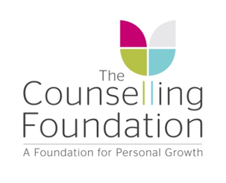
How to join the St Albans Charity Cycle Ride
and raise funds on behalf of the Foundation
- Visit the St Albans Charity Cycle Ride (SACCR) website: saccr.co.uk
- Click the header ‘Enter Event’.
- Click on ‘Enter Online’ button top right.
- Follow the instructions to add your details.
- You will be asked to pick your distance to cycle 10, 20 or 30 miles
- Entry fees: Adult £22, Youth (under 16) £5, Senior (over 65) £10.
- To collect sponsorship on behalf of the Foundation please visit Virgin Money Giving to set up your own Virgin Money Giving page.
- Click on ‘Start Fundraising’ button near the top right.
- Sign in with your email address
- Follow the instructions to set up your personalised page.

- Please let us know you are joining our team of sponsored cyclists so we can keep you up to date with event news.

- Let your friends and family know about your challenge. If you are happy to share on social media please use these hashtags: #saccr #cyclingrotary #yellowcycleride #charitycycleride #StAlbans
- For more information please visit our website or contact us know if you need any help with signing up: judy.mallinson@counsellingfoundation.org or 01727 868585 Option 7
Follow us:

Thank you for helping make long term counselling available to anyone experiencing anxiety, depression or grief.

